JDA Virtual POS
This document describes the implementation of a “Virtual POS” application, which is intended to support copying done at Office Depot with self-serve copiers. These copiers allow copying transactions to be completed without cashier input.

The design goals for the JDA Virtual POS are the following:
- Provide an automated transaction service which supports price lookup, and transaction creation and completion, without requiring cashier input.
- Integrate the automated transaction service to meet the requirements for self-serve copiers at Office Depot.

Version History
June 8, 2009 – Original version
July 21, 2009 – Added details of design of automated transaction service

Contents
JDA Virtual POS 1
Version History 1
Contents 1
Business Scenario – Self-serve copier 1
Automated transaction service 4
Class design 5
Web Service 10
Testing automated transaction service 11
Exception Handling 13
Virtual POS Service 15
Requirements and work breakdown 15
Issues 21
Appendix – Output XML from Price Lookup example 22
Appendix – Input and Output XMLs for Transaction Creation 24
References 28

Business Scenario – Self-serve copier
This use case describes the process for using the self-serve copier to generate POS transactions, as defined by Office Depot.

- Customer walks up to self-serve copier machine.
- Customer swipes credit card or gift card.
- If approved, customer will be prompted for additional data:
- Does the customer have a loyalty or Star Teacher number?
- Does the customer have a tax ID number?
- Does the customer have any coupons?
- Customer loads originals.
- Customer selects copy configuration.
- Customer selects job is ready for copying.
- Customer approves price for the copy job (pre-tax and applicable discounts).
- Copier prints job.
- Repeat steps 7-11 for each copy job the customer wants to complete.
- Transaction is completed, and copier prints a receipt which summarizes the transaction.

The components which are involved in this use case are shown in Figure 1. In addition to the customer and the copier, the key components are:
- The Equitrac application is a third-party application which manages the interactions between each copier and the POS application. Equitrac resides in a central location and communicates with copiers which are placed in various locations across the enterprise.
- The Mainframe is used in this scenario for credit authorization, using the AJB authorization provider. The Virtual POS sends credit authorizations to the Mainframe as part of the process of tendering a transaction.
- The POS Store Server runs at each Office Depot location. It will contain the services needed to perform price lookup and transaction creation, based on the work done at each copier.

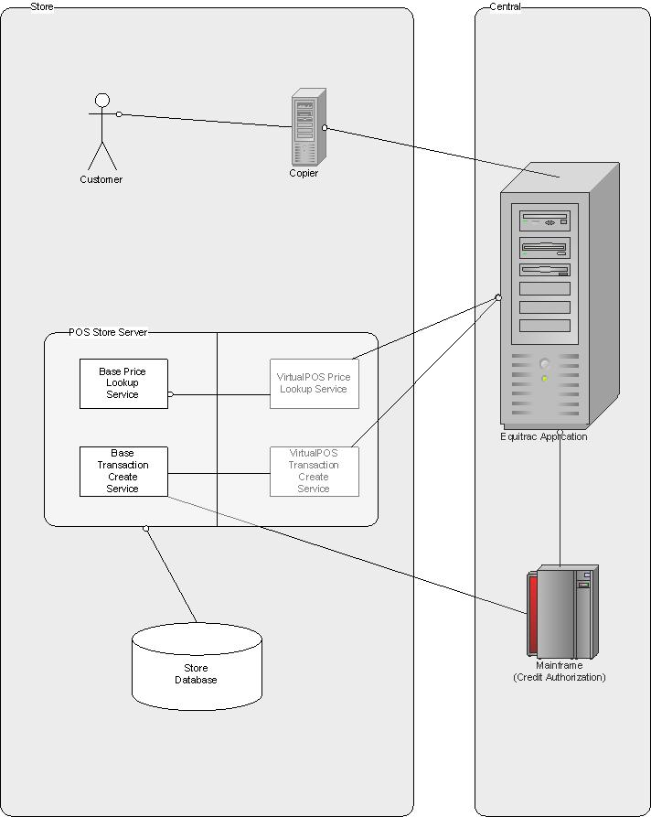
Figure 1: Component diagram for business scenario

The POS Store Server provides two services for use in the Virtual POS, a price lookup service and a transaction creation service. The price lookup service will verify that a provided SKU is in fact valid, and that it has a valid price. The transaction creation service will create and store a POS transaction to reflect the copying which was done by the customer.

For each of these services, we provide a base service plus an integration service, which provides the specific implementation for the Virtual POS. The base service has been designed so that it can be used in other scenarios beside the Virtual POS. The integration service is responsible for managing the communication with the Equitrac application. It will invoke the base service as needed.

Automated transaction service
The base services are implemented by an automated transaction service, which is being developed as part of the base POS product. The automated transaction service allows for transactions to be generated from a specification of a transaction. The requirements for this automated transaction service are shown below.

- Define and implement an XML-based interface for a price lookup service. The XML will be designed based on the capabilities of the POS application. The inputs will include:
  - Product SKU(s)
  - Any promotional events or coupons which may apply
  - Customer identifier
The XML outputs will include:
- Prices for each input product SKU
- Taxes which apply for each product SKU
- For each coupon, an indication of whether or not the coupon is valid
- A status indicator used to identify whether the service completed without exceptions
- Any exceptions encountered while running the service
- Define and implement an XML-based interface for a transaction creation. The XML will be designed based on the capabilities of the POS application. The inputs will include:
  - A collection of Product SKU and quantity indicators
  - Any promotional events or coupons which may apply
  - Tendering information
  - Customer identifier
The XML outputs will include:
- Prices for each input product SKU
- Taxes which apply for each product SKU
- For each coupon, an indication of whether or not the coupon is valid
- A status indicator used to identify whether the service completed without exceptions
- Any exceptions encountered while running the service

The automated transaction service consists of:
- Enterprise Java Beans (EJBs) to generate transactions and perform price lookups without any user input, based on a transaction specification object which is input to the service’s methods.
- A Web Service for client applications to submit transaction specifications, and receive back transaction or price lookup results. A client application which seeks to use the automated transaction service should invoke the Web Service, which will call the EJBs as necessary to perform the transaction and price lookup actions. The input and output formats of the web service are XML messages.

Class design
The automated transaction service will use a set of objects for representing transactions and price lookups. The same classes will be used for both transactions and price lookups, because price lookups are essentially a subset of what is needed to process transactions.

The classes which are used as inputs to the automated transaction service are shown in Figure 2. The primary input class is the TransactionSpec. This class will contain all of the information which is necessary to define a transaction or a price lookup. The information elements are defined in the following table:

TransactionSpec
Element | Explanation | Price Lookup | Create Transaction
transClassName | Defines the type of transaction to be created. For Virtual POS, this value will be com.jda.portfolio.pos.base.transaction.RetailTransaction. | Mandatory | Mandatory
locationNumber | Defines the location where the transaction takes place. | Mandatory | Mandatory
currencyCode | Currency used in transaction. If not provided, home currency of location will be used | Optional | Optional
AssociateSpec | Associate information | Mandatory | Mandatory
terminalName | Defines the terminal for this transaction. For Virtual POS, each copier is assumed to be added to the store’s terminal table, and the copier identifier from Equitrac is the terminal name. | Mandatory | Mandatory
CustomerSpec | Customer information. If no customer spec is provided, the automated transaction service may still try to identify the customer from a credit card number, since credit card number may be used as a customer identifier. | Optional | Optional
LineItemSpecs | Collection of LineItemSpec. | Mandatory (at least one LineItemSpec) | Mandatory (at least one LineItemSpec)
CouponSpecs | Collection of CouponSpec | Optional | Optional
DiscountSpecs | Discounts which apply to the entire transaction | Optional | Optional
TenderSpecs | Collection of TenderSpec | Optional | Mandatory (except for Virtual POS price override scenario)

AssociateSpec
Element | Explanation | Price Lookup | Create Transaction
associateNumber | Associate responsible for the transaction. | Mandatory | Mandatory

CustomerSpec
Element | Explanation | Price Lookup | Create Transaction
customerNumber | Defines the customer for this transaction. | Mandatory | Mandatory
taxExemptNumber | Used to exempt customer from taxes | Optional | Optional

LineItemSpec
Element | Explanation | Price Lookup | Create Transaction
sku | Product identifier. May be UPC or SKU | Mandatory | Mandatory
quantity |  | Mandatory | Mandatory
overridePrice | Specific price to be assigned | Optional | Optional
pricePrecision | If not provided, currency precision will be used. | Optional | Optional
overrideReasonCode | Reason associated with price override. For VirtualPOS, the accepted values will be a subset of all price override reason codes | Mandatory if overridePrice is provided. Optional otherwise. | Mandatory if overridePrice is provided. Optional otherwise.
DiscountSpecs | Discounts which apply to this line item. | Optional | Optional.

DiscountSpec
Element | Explanation | Price Lookup | Create Transaction
discountCode | Type of discount. | Mandatory | Mandatory
amount | Amount of discount. May be mandatory, depending on the discount code. | Optional | Optional
Precision | Precision of discount amount. If not provided, currency precision will be used. | Optional | Optional

CouponSpec
Element | Explanation | Price Lookup | Create Transaction
couponNumber | Coupon identifier | Mandatory | Mandatory

TenderSpec
Element | Explanation | Price Lookup | Create Transaction
tenderCode | Indicates type of tender | Not needed | Optional
cardNumber |  | Mandatory | Mandatory
expiryDate |  | Not needed | Mandatory
track1Data |  | Not needed | Mandatory
track2Data |  | Not needed | Mandatory
track3Data |  | Not needed | Optional
preLockNumber | Used for completing pre-auths started by Equitrac | Not needed | Optional
preLockAmount | Used for completing pre-auths started by Equitrac | Not needed | Optional
amount | Amount of tender. If not provided, tender is for transaction balance. | Not needed | Optional
precision | Precision for tender amount. If not provided, currency precision is used. | Not needed | Optional

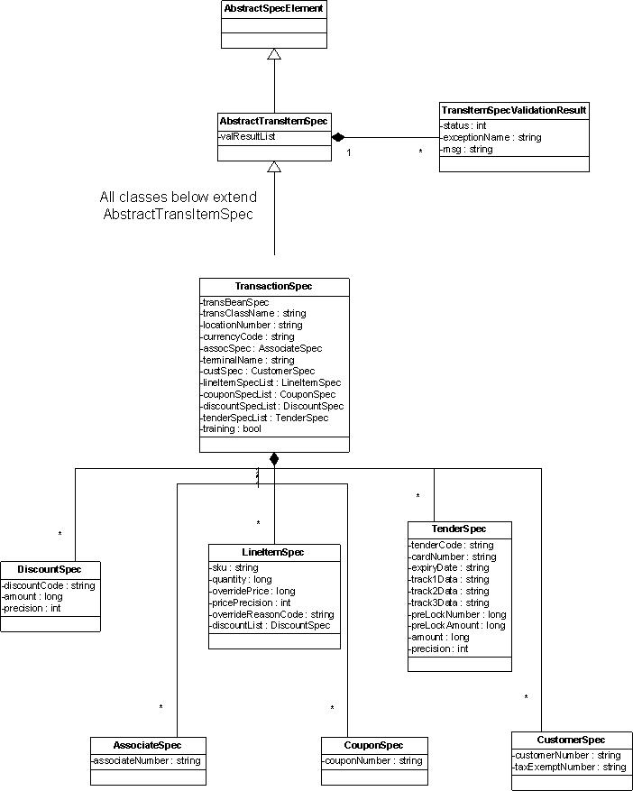
Figure 2: Classes used as inputs to automated transaction service

The classes defined in Figure 2 are the following:

AbstractSpecElement – Abstract superclass of all input and output objects.

AbstractTransItemSpec – Abstract superclass for all input objects. Contains a list of validation results, so for each input, we can associate any exceptions with the input information.

TransItemSpecValidationResult – This class defines a validation result for a specific input object.

TransactionSpec – The primary input object for the automated transaction service. It defines the transaction or price lookup as a whole. It contains the specification of other items which make up the transaction. This class, and all of the following classes, extend the AbstractTransItemSpec class.

LineItemSpec – Defines a specific product for a price lookup or transaction.

TenderSpec – Defines a specific tender for a transaction. For a price lookup, the tender spec may contain only the card number.

AssociateSpec – Defines the associate for a price lookup or transaction.

CustomerSpec – Defines a specific customer for a price lookup or transaction.

CouponSpec – Defines a coupon to be applied to a price lookup or transaction.

DiscountSpec – Defines a discount for a line item or the entire transaction. Used for transactions only.

The classes which are defined as outputs for automated transaction service are shown in Figure 3. The TransactionSpec class, which defines the primary input object, also is the primary output object. The TransactionSpec class contains a series of Trans*Spec classes. Each of these classes maps to the equivalent Trans* table in the database. The TransactionSpec is updated with a TransBeanSpec (which maps to the Trans header table). The TransBeanSpec directly or indirectly contains the classes which map to the other transaction tables in the database.

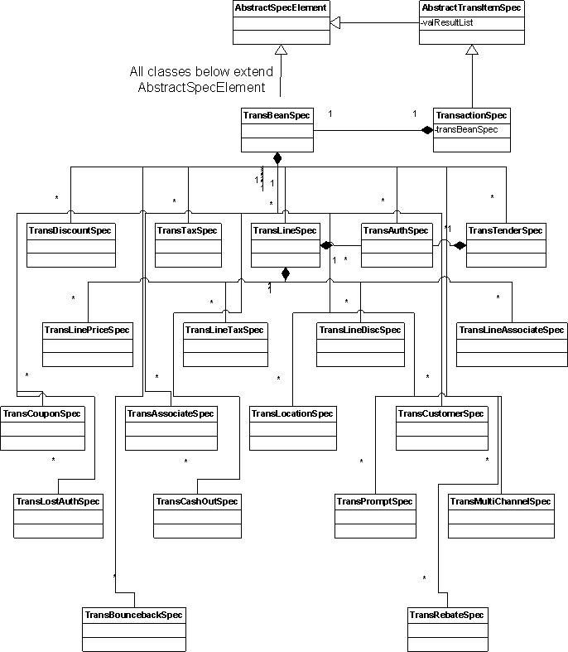
Figure 3: Output objects for automated transaction service

Web Service
The web service for automated transactions is built with the RESTEasy system. RESTEasy provides frameworks for building RESTful Web Services and Java applications. It is a fully certified and portable implementation of the JAX-RS specification.

The XML specification for the web service is defined in PPOS\PPOS\Base\src\com\jda\portfolio\pos\base\transaction\autotrans\autotrans.xsd. This file is checked into NPD’s source code control system. The XSD was generated automatically from the TransactionSpec input and output classes. Those classes use annotations on classes and “get” accessors to define the XML tags that are defined in the XSD.

The web service is being deployed as part of the base 7.6.1 deliverable of POS, in a new war file called pposautoservices.war. This war defines a servlet called PPOSAutomationServlet, which defines the RESTEasy resources in a class called AutoTransactionResource. This class includes methods to perform price lookup and transaction creation, which are mapped to the URLs used by the client app to invoke those services.

For more information about the web service for the automated transaction service, or for more information about RESTEasy, please check out the following links.

http://tx1ppos01:8080/PPOSWiki/Wiki.jsp?page=AutomatedTransactionService

http://tx1ppos01:8080/PPOSWiki/Wiki.jsp?page=RESTServicesOverview

Testing automated transaction service
To test the automated transaction service, you must define:
- XMLs which represent the input for a price lookup or transaction.
- Invoke the Web Service with the appropriate URLs and XMLs. The easiest way to do this is to write a program that invokes a HTTP client to invoke the web service.

Here is an example of invoking the automated transaction service to perform a price lookup.

<TransactionSpec>
<transClassName>com.jda.portfolio.pos.base.transaction.RetailTransaction</transClassName>
<locationNumber>8001</locationNumber>
<AssociateSpec>
<associateNumber>102</associateNumber>
</AssociateSpec>
<terminalName>33</terminalName>
<LineItemSpecs>
<LineItemSpec>
<sku>201</sku>
<quantity>1</quantity>
</LineItemSpec>
</LineItemSpecs>
<TenderSpecs>
<TenderSpec>
<cardNumber>5555555555555557</cardNumber>
</TenderSpec>
</TenderSpecs>
</TransactionSpec>
Listing 1: Input XML for a price lookup

<TransactionSpec> shows the XML which is used to perform a price lookup. It defines a transaction spec with
- Transaction class name
- Location number
- Associate number
- Terminal name
- A single line item for SKU 201 with a quantity of 1
- A tender spec with a card number (which can be used for a customer lookup)

Next, we need to write some Java code to invoke the web service.

try {
HttpClient aClient = new HttpClient();
PutMethod aPut = new PutMethod(
"http://localhost:7001/pposautoservices/transaction/price");
aPut.addRequestHeader("ppos-user", PPOS_USER);
aPut.addRequestHeader("ppos-pswd", PPOS_PASSWORD);
aPut.setRequestEntity(new StringRequestEntity(
xmlData, "application/xml", "UTF-8"));
int status = aClient.executeMethod(aPut);
InputStream responseStream = aPut.getResponseBodyAsStream();
StringBuilder responseBuffer = new StringBuilder();
for (int ch = responseStream.read(); ch >= 0;
ch = responseStream.read())
{
responseBuffer.append((char) ch);
}
…
}
catch (HttpException httpe)
{
System.out.println("Http exception: " + httpe);
httpe.printStackTrace();
}
catch (IOException ioe)
{
System.out.println("IO exception: " + ioe);
ioe.printStackTrace();
}
catch (Exception e)
{
System.out.println("Exception: " + e.getMessage());
e.printStackTrace();
}
Listing 2: Code to invoke automated transaction web service

This code does the following:
- Creates a HTTPClient object for invoking the web service
- Defines the PutMethod to be sent to the HTTPClient, which includes the URL used to invoke the web service. The machine name may change, but the remainder of this URL should work for your installation.
- Adds a request header for the PPOS User and PPOS Password. These fields are mandatory, and will be used by the web service to authenticate the request.
- Sets the request data to the XML representing the input object. The variable “xmlData” has been set to the XML from Listing 1.
- Invokes the web service, through the call to “aClient.executeMethod(aPut)”
- Gets the response body from the put method, and reads this response body to obtain the output XML.

For a completed transaction, the steps would be the same, except the URL used to create the PutMethod would be set to “http://localhost:7001/pposautoservices/transaction/create”. The URL is similar, except that “/create” is used to invoke a completed transaction, and “/price” is used to invoke a price lookup.

The output XML would also be a TransactionSpec, but would also include all of the Trans*Spec elements. The output from this example is shown in Listing 3, in the Appendix.

Exception Handling
The automated transaction service will verify the data in all input XMLs (for example, making sure that any SKUs entered are actual products with a defined price), plus handle exceptions that arise during the processing of the service. For any exceptions or validation errors, a TransItemSpecValidationResult instance will be created, and added to the appropriate input object. The TransItemSpecValidationResult object has the following instance variables:
- Status – Indicates the overall result of the process resulting from this result. Status may have any of the following values:
  - 0 = Transaction or price lookup completed as expected
  - 1 = Transaction created but was set to suspended state.
  - 2 = Transaction created but was voided
  - 3 = Error. Transaction or price lookup failed. No transaction was created.
- Exception Name – Indicates the type of exception. There is a small set of allowed exception names, explained below.
- Msg – Additional information about the specific exception.

These are the possible types of exceptions which could be set as the Exception Name

Missing or Invalid Information – The input XML does not contain enough information to complete processing. The status will be set to Error. The examples of missing information are:

TransactionSpec:
- No trans class name is provided, or it does not represent a valid subclass of AbstractTransaction
- No location number is provided, or it does not represent a valid location.
- No associate spec or associate number is provided, or the associate number does not represent a valid associate
- No terminal name is provided, or it does not represent a valid register
- No line item specs are provided
- No tender spec is provided (for a completed transaction), or more than one tender spec is provided

LineItemSpec:
- No SKU is provided, or it does not represent a valid product
- No quantity is provided
- No price can be found for a product, and no override price is provided
- Override price is provided but no reason code is provided
- Override reason code does not represent a valid reason code

TenderSpec:
- No card number is provided, or it does not represent a valid card
These apply to completed transactions only, not price lookups
- No expiry date is provided, or it is not a valid expiry date
- No track 1 data is provided
- No track 2 data is provided

AssociateSpec:
- No associate number is provided, or it does not represent a valid associate

CustomerSpec:
- No customer number is provided, or it does not represent a valid customer

CouponSpec:
- No coupon number is provided, or it does not represent a valid price event

DiscountSpec:
- No discount code is provided, or it does not represent a valid discount code
- Discount type requires amount, but no amount is provided

Authorization Timeout – As part of a completed transaction, the authorization of the payment times out. Status is set to Suspend, and the transaction is suspended.

Authorization Provider Offline – As part of a completed transaction, the authorization of the payment fails because the auth provider is offline. Status is set to Suspend, and the transaction is suspended.

Authorization Decline – As part of a completed transaction, the authorization of the payment is declined by the auth provider. Status is set to Suspend, and the transaction is suspended.

Authorization Referral – As part of a completed transaction, the authorization of the payment is given a status of referral by the auth provider. If the amount of the authorization is below the card’s manual floor limit, the authorization is auto-approved, and the transaction should complete normally. If the amount is over the card’s manual floor limit, the Status is set to Suspend, and the transaction is suspended.

Authorization Insufficent Balance – As part of a completed transaction, the authorization of the payment shows an approval for a balance less than that of the transaction. Status is set to Suspend, and the transaction is suspended.

Authorization Exception – As part of a completed transaction, the authorization of the payment has an unknown exception while authorizing. Status is set to Suspend, and the transaction is suspended.

Miscellaneous Transaction Exception – As part of a completed transaction, an unknown exception occurs. If a transaction exists, it is set to voided, and the Status is set to Voided. If no transaction exists, then the Status is set to Error.

Miscellaneous Price Lookup Exception – As part of a price lookup, an unknown exception occurs. The Status is set to Error.

Virtual POS Service
The actual Virtual POS service will be developed outside of the base POS application, since it involves business rules and process which are specific to a single customer. Virtual POS will invoke the automated transaction service as part of its processing. The requirements for the Virtual POS service are:

- Define and implement a web service which can be called from the Equitrac application to provide the price lookup and transaction creation services. The inputs and outputs of this service should conform to the XML specs as defined by Office Depot for the Virtual POS.
- Invoke the corresponding base services to perform the specific functionality. This involves building an adapter layer, which maps the XML formats provided by Office Depot to the XML formats supported by the automated transaction service’s web service.
- Implement any business logic which is specific to the Virtual POS scenario. One example is limitations on the types of tenders which can be supported by the Virtual POS.
- Define and implement an external service for representing the web service. The definition of the external service should include parameters for accessing the web service.
- Allow for the web service to be deployed and installed as part of a new installation of POS, or an upgrade of an existing POS installation; while minimizing any performance impacts on organizations which use POS, but who will not use the Virtual POS functionality.

Requirements and work breakdown
The Statement of Work for the Virtual POS project describes the various subsystems which are used in the self-serve copying scenario described at the beginning of this document. JDA is responsible for providing a Virtual POS application. Below is a list of the specific requirements for Virtual POS. For each requirement, there is a discussion of what work needs to be done to meet this requirement. This discussion breaks down the work into responsibilities for NPD (Automated transaction service) and CSG (customer-facing Virtual POS Service).

- Create a new POS engine as virtual POS on the W10 server to receive TCP/IP XML formatted message from Equitrac server for the copy machine transaction data. This virtual POS running on W10 server at store will not
require any GUI input.
NPD: Provide automated transaction service, which is being designed for potential reuse in other applications
CSG: Provide Virtual POS service, which manages the interfaces with the Equitrac copying application, and invokes the automated transaction service for price lookup and transaction creation. Maps inputs from Equitrac to XMLs which are sent to the automated transaction service, and maps output XMLs from the automated transaction service to the format supported by Equitrac.

- The customer credit card data from Equitrac will be processed by the virtual POS, which will send the authorization message to the Office Depot mainframe gateway for authorization as performed today.
NPD: Perform authorization using the authorization provider used by Office Depot in its POS application.
CSG: Provide credit card data in a form to the automated transaction service, so the authorization can take place.

- All credit card and OD gift Cards will be accepted tenders excluding Debit (this also excludes Credit Gift cards such as Amex, Visa & MasterCard – they will be declined at the gateway pre-auth)
NPD: Automated transaction service will accept any valid card as a tender.
CSG: Verify that the card number submitted by the customer conforms to one of the accepted tender types.

- No PIN Debit entry available at the copier.
NPD: No action needed
CSG: No action needed (assuming Debit is precluded from being tendered)

- No signature required for any tenders
NPD: No action needed
CSG: No action needed

- Customer name should be tlog’d from track 1 (this is current process used at POS)
NPD: Extract customer name from track 1 text
CSG: Provide track 1 text to automated transaction service in decrypted form

- The virtual POS creates the xml sales file base on the ITEM, QTY and credit card data from Equitrac. POS uses the copier ID number 20 - 30 and will create the xml sales file into the same folder on W10 as other registers for ordered tlog to process. POS tlog the credit card data as encrypted, masked and hashed forms in xml sales file, this is same as the other register credit transactions.
NPD: Create a POS transaction for each transaction sent from Virtual POS service. Transaction will be stored in store server database (and sent to central server for storage in central database), the same as any other POS transaction rung up at the register. Existing mechanisms for encrypting credit card data will be used by the automated transaction service.
CSG: Create entries in Terminal table for each copier which can send data to Virtual POS through Equitrac.

- Create DPS Debug log for tracking message data sent between the Equitrac Application and virtual POS.
NPD: Log activity of automated transaction service, including any exceptions or special circumstances.
CSG: Log message traffic between Virtual POS and Equitrac.

- The virtual POS will apply any transaction discounts, loyalty discounts, tax exemption and re-price to qualified transaction from Equitrac. PO# will also be logged if returned with SPC account.
NPD: Automated transaction service applies discounts and tax exemptions as needed, and computes the correct price based on all information included in the transaction.
CSG: No additional action needed.

- Equitrac will pass the loyalty ID number in the transaction message to POS to apply any loyalty discount. POS does the lookup as part of normal calculating process discounting if it is a valid number and logs the appropriate loyalty message to the copier receipt. Same loyalty/versus CC tied to loyalty rules apply.
  - Keyed loyalty/star teacher number takes precedence over loyalty found via credit card lookup on the mainframe.
NPD: Use the following process to identify a customer to be associated with a transaction or a price lookup:
If a customerNumber is provided in a CustomerSpec, in the input XML, then the customer number is used to locate the customer. If no customer is found, then this is a validation exception, and the processing will not be completed.
If no customerNumber is provided, but a card number is provided in the TenderSpec, in the input XML, then the card number is used to locate the customer. If no customer is found, then the automated transaction service assumes there is no customer to be attached to the transaction or price lookup.
CSG: Properly format the customerNumber, based on input from Equitrac.

- In the case where virtual POS receives a “timeout”, “offline” or “provider down” response message from host for the credit authorization request it will follow the floor limit approval process; if below floor limit ($150) give auto approval and allow completion of transaction and send completed receipt to Equitrac. If over the floor limit, suspend the transaction and send receipt with notification to Equitrac that further action is required.
NPD: Return a validation result with the tender spec which indicates Authorization Timeout. Suspend the transaction without adding any tenders.
CSG: Translate the Authorization Timeout result into an appropriate message for Equitrac.

- In the case where the virtual POS receives a “decline” or “referral” response message from the host for the credit authorization request it will suspend the transaction and send receipt with notification to Equitrac that further action is required.
NPD: If authorization is declined, then return a validation result with the tender spec which indicates Authorization Decline. Suspend the transaction without adding any tenders.
If authorization response is referral, and auth amount is below the manual floor limit for that particular card, auto-authorized the tender and proceed with the transaction.
If authorization response is referral, and auth amount is greater than or equal to the manual floor limit for that particular card, then return a validation result with the tender spec which indicates Authorization Referral. Suspend the transaction without adding any tenders.
CSG: Translate any Authorization Decline or Authorization Referral result into an appropriate message for Equitrac.

- After virtual POS finishes processing the transaction, POS will create a receipt text file (XML format determined by GTS) and transfer the file to Equitrac server for receipt printing. See below for receipt requirements.
NPD: Provide XML output from automated transaction service invocation.
CSG: Translate XML output from automated transaction service into file format to be sent to Equitrac server.

- Equitrac will need to send the copier identifier (Register ID 20 – 30) in the message to POS, POS will parse the copier identifier from the message and tlog in the XML sales file, the back end ordered tlog will add the copier identifier continuation to the base header record for sales accounting log.
NPD: No additional action required.
CSG: Ensure a record in the Terminal table exists for each copier which can send messages to Equitrac.

- Virtual POS will have a folder on W10 for each copier id that will log the tg0 transactions and copy into the c:\store\db\tlog folder as tg1 for the ordered tlog process.
NPD: Store transactions created through Virtual POS in store and central databases.
CSG: No additional action needed.

- In the event the tg0 file creation fails, virtual POS will create the raw transaction file in the same folder on the W10 where the other regular registers copy the raw transaction files to. The back end re-stage process will pick up the transaction file and process into a tg1 file for the ordered tlog.
NPD: Existing processes for managing transactions which cannot be stored to database will be used.
CSG: No additional action needed.

- Employee ID to be used on all Virtual POS transactions is “111111”.
NPD: No additional action needed.
CSG: As part of store configuration, create an associate with an associate number of ‘111111’. In the input XML for the automated transaction service, included an <AssociateSpec> element whose <associateNumber> value is set to “1111111”.

- Virtual POS only processes the final approval credit response that will be passed to settlement. Credit pre-auth will be handled directly between Equitrac and the Mainframe.
NPD: Perform authorization as part of transaction creation done through automated transaction service.
CSG: No additional action needed.

- Add support for Store Forward on OD Gift cards
NPD: Ensure Store Forward is supported for OD Gift cards processed through automated transaction service.
CSG: No additional action needed.

- Support 1st lookup for sku pricing, tax table(s) descriptor , coupon validation and credit card lookup against poscred.xml file for PO prompting.
  - If any sku’s are flagged for more than one tax table, virtual POS will pass back both tax table descriptors to Equitrac and then Equitrac will parse out the percentage and add them together.
  - Coupon validation will send back the coupon number along with approval/decline or expired indicator for each.
NPD: Perform price lookup through automated transaction service. For a price lookup, no transaction will be logged to the database, nor will a transaction number be generated. Internally, POS will use many of the same objects for transaction creation and price lookup, with the exceptions noted above.
CSG: Format appropriate <LineItemSpec> and <CouponSpec> elements as part of input XML to automated transaction service.

- Add support for new message types on OD Gift card pre-auth lock – 09 pre-auth complete. Should be able to update current message sent to gateway.
NPD: Support new message type 09 pre-auth complete, for OD gift cards.
CSG: Provide pre-lock number and amount as part of <TenderSpec> XML input to automated transaction service.

- Add support for manually entered coupons, loyalty id, tax id and employee id entered at the copier and passed by Equitrac to Virtual POS.
NPD: Coupons are processed from <CouponSpec> elements of input XML to automated transaction service.
Loyalty ID is processed as a <customerNumber> value in <CustomerSpec> element of input XML.
Tax exemption ID is processed as <taxExemptNumber> value in <CustomerSpec> element of input XML.
Employee ID is processed as <associateNumber> value in <AssociateSpec> element of input XML.
CSG: Format input XML values as needed.

- If any part of the message from Equitrac to the Virtual POS is missing, such as, copy count, sku’s and/or tender data. Virtual POS will send an error message back to Equitrac in order for Equitrac to resend a complete message. No tlog entry will be created unless entire message is resent.
NPD: Will create validation result objects, and add to the XML output, for the appropriate element within the XML (<TransactionSpec> for validation results which apply to the entire transaction, <LineItemSpec> for validation results which apply to a specific line item, etc.). The result object will have one of the following exception types:
Missing or Invalid Information
Authorization Exception
Miscellaneous Price Lookup Exception
Miscellaneous Transaction Exception
CSG: Locate validation result elements in output XML and map to appropriate output messages to be sent to Equitrac.

- Will default the SKU item entry as SCAN, and Credit Card entry as MSR
NPD: These values will be set by the automated transaction service.
CSG: No additional action needed.

- On Gift Card tenders if transaction total is greater than available balance on card, suspend transaction as insufficient funds (no charging of funds will be taken off card due to POS cannot suspend after tender) and send suspended receipt to Equitrac in order for the customer to take to the register to have transaction resumed and pay.
NPD: Return a validation result with the tender spec which indicates Authorization Insufficient Balance. Suspend the transaction without adding any tenders.
CSG: Translate the Authorization Insufficient Balance result into an appropriate message for Equitrac.

- Create in-store reporting for un-resumed DPS transactions. All suspended transactions are deleted during store close process.
NPD: No additional action needed.
CSG: Either a custom report will be needed for un-resumed DPS transactions, or existing reports will need to be modified to identify suspended transactions on the “copier” registers. Also, an end of day task will be needed to purge suspended transactions from the “copier” registers.

- DPS Employee Assisted Transaction logging – This will be a transaction which logs similar to a POS price override, but logs price as zero in order to create a tlog entry and receipt for tracking.
  - No tender will be required since balance due will be zero.
  - Employee id will be passed by Equitrac to be used as override id (no password logging required) for tlog
  - Reason codes setup for this function and can only come from the DPS are:
09 – Customer Satisfaction/Price Match, 10 – Store Use, 11 – Full Service Overflow
NPD: Make the automated transaction service support a transaction with a SKU having a price override of 0, and no tender information. In this case, a transaction will be created and stored in store database.
CSG: Configure price override reason codes representing the values defined above. Validate input from Equitrac so that only these reason codes are allowed.

- GTS to provide XML layout for all data sent from the Equitrac application to the virtual POS.
NPD: Publish XSD with layout of inputs and outputs to automated transaction service.
CSG: Publish XML layouts for all data used as inputs and outputs from Equitrac.

- Multi/split tender Not Supported
NPD: Automated transaction service will only allow one tender, for the complete amount of the transaction.
CSG: No additional action needed.

- TPI is not supported
NPD: No additional action needed.
CSG: No additional action needed.

- Virtual POS will not send receipt logo to Equitrac (logo will reside on Equitrac server)
NPD: No additional action needed.
CSG: No additional action needed.

Addendum – Receiving Encrypted Data from Equitrac – 12/9/2008
- Receive Equitrac final transaction message credit data encrypted. Following data need send from Equitrac to Virtual POS for credit card data:
o Tender Type
o Pseudonym name of RSA public key
  - Encrypted track 2 data
  - Hashed track 2 data
  - Encrypted credit card number
  - Hashed credit card number
  - Masked credit card number
- Encryption is only for Third Party Credit Cards (Visa, Master, Amex, Discover)
- Update POS for encrypted credit data from Equitrac.
- Update POS to use masked credit card number from Equitrac message for receipt print and EJ log.
- Update POSCred to bypass the credit card bin range validation for DPS transaction only, use encrypted, hashed track 2 and credit card number data received from Equitrac for host credit request.
NPD: The automated transaction service requires unencrypted card data in order to complete an authorization. The requirements in this addendum directly contradict a recent message we received from Office Depot stating that Virtual POS can use unencrypted card data. As such, we do not feel we can meet these requirements as stated.
CSG: ???

Issues
- For the POS transaction service to process a copier transaction, it must have access to the decrypted credit card information, since part of processing the copier transaction is to authorize the tendering based on the card information provided. Our understanding is that Office Depot is implementing its own encryption algorithm, and that once encrypted, credit card information can not be decrypted by an applications running at the store (such as Virtual POS). Further, our understanding is that no decrypted credit card data can be sent “over the wire” from one application to another. JDA must work with Office Depot to identify a means for obtaining the decrypted credit card information.
- NPD needs to understand the requirement associated with store and forward of OD gift cards. This may or may not involve some additional work to the AJB interface for Office Depot.
- NPD needs to implement the ability to complete a pre-auth. This will require additional work to the AJB interface for Office Depot, since this message type is not supported.

Appendix – Output XML from Price Lookup example
<?xml version="1.0" encoding="UTF-8"?>
<TransactionSpec training="false">
<ResultSpecs/>
<AssociateSpec>
<ResultSpecs/>
<associateNumber>102</associateNumber>
</AssociateSpec>
<CouponSpecs/>
<DiscountSpecs/>
<LineItemSpecs>
<LineItemSpec>
<ResultSpecs/>
<DiscountSpecs/>
<quantity>1</quantity>
<sku>201</sku>
</LineItemSpec>
</LineItemSpecs>
<locationNumber>8001</locationNumber>
<TenderSpecs>
<TenderSpec>
<cardNumber>5555555555555557</cardNumber>
</TenderSpec>
</TenderSpecs>
<terminalName>33</terminalName>
<TransBeanSpec training="false">
<allTaxesExempt>false</allTaxesExempt>
<allTaxesOverridden>false</allTaxesOverridden>
<TransAssociateSpecs>
<TransAssociateSpec>
<associateLineId>1</associateLineId>
<associateNumber>102</associateNumber>
<associateType>1</associateType>
<firstName>Start</firstName>
<lastName>Associate</lastName>
</TransAssociateSpec>
</TransAssociateSpecs>
<TransBounceBackSpecs/>
<businessDate>2009-07-20T12:00:00-05:00</businessDate>
<calculationStats>1,PDPE/109/1/1/4/1,</calculationStats>
<TransCashOutSpecs/>
<changeAmount>0</changeAmount>
<TransCouponSpecs/>
<discountRule>com.jda.portfolio.pos.base.transaction.discount.CompoundedDiscountRule</discountRule>
<TransDiscountSpecs/>
<endDatetime>2009-07-20T13:59:24.661-05:00</endDatetime>
<endOffline>false</endOffline>
<externalPriceLookupSuccess>0</externalPriceLookupSuccess>
<GSACustomer>false</GSACustomer>
<grossSalesAmount>4279</grossSalesAmount>
<idSwiped>false</idSwiped>
<language>en_US</language>
<lineCorrectionAmount>0</lineCorrectionAmount>
<lineCorrectionCount>0</lineCorrectionCount>
<lineItemCount>1</lineItemCount>
<lineRefundAmount>0</lineRefundAmount>
<lineRefundCount>0</lineRefundCount>
<TransLineSpecs>
<TransLineSpec>
<TransLineAssociateSpecs/>
<description>Ultimo Combat</description>
<discountTotal>0</discountTotal>
<TransLineDiscSpecs/>
<GSAItem>false</GSAItem>
<giftReceipt>false</giftReceipt>
<itemType>1</itemType>
<lineDeleted>false</lineDeleted>
<openGc>false</openGc>
<postTaxDiscountAmount>0</postTaxDiscountAmount>
<TransLinePriceSpecs>
<TransLinePriceSpec>
<alternatePriceBook>false</alternatePriceBook>
<amount>3999</amount>
<amountPrecision>2</amountPrecision>
<confirmPrice>false</confirmPrice>
<eventName>Regular prices</eventName>
<eventNumber>100</eventNumber>
<externalPriceLookupSuccess>false</externalPriceLookupSuccess>
<originalAmount>3999</originalAmount>
<originalEventNumber>100</originalEventNumber>
<priceBookNumber>RET</priceBookNumber>
<priceType>300000</priceType>
<promotional>false</promotional>
</TransLinePriceSpec>
</TransLinePriceSpecs>
<TransLinePromptSpecs/>
<quantity>1</quantity>
<quantityPrecision>0</quantityPrecision>
<refund>false</refund>
<remainder>0</remainder>
<returnTotal>3999</returnTotal>
<serializable>false</serializable>
<shortDescription>Ultimo Combat</shortDescription>
<sku>201</sku>
<taxArea>AB</taxArea>
<TransLineTaxSpecs>
<TransLineTaxSpec>
<abbrCode>G</abbrCode>
<exempt>false</exempt>
<inclusive>false</inclusive>
<overridden>false</overridden>
<receiptCode>G</receiptCode>
<taxAmountPrecision>0</taxAmountPrecision>
<taxAuthority>Fed</taxAuthority>
<taxCode>GST</taxCode>
<taxId>1</taxId>
<taxRatePrecision>0</taxRatePrecision>
<taxType>0</taxType>
</TransLineTaxSpec>
</TransLineTaxSpecs>
<total>3999</total>
<transLineId>1</transLineId>
<transLineType>500000</transLineType>
</TransLineSpec>
</TransLineSpecs>
<locationNumber>8001</locationNumber>
<TransLocationSpecs>
<TransLocationSpec>
<amountPrecision>2</amountPrecision>
<homeCurrency>USD</homeCurrency>
<locationLineId>1</locationLineId>
<locationName>Start Store</locationName>
<locationNumber>8001</locationNumber>
<locationType>1</locationType>
</TransLocationSpec>
</TransLocationSpecs>
<TransLostAuthSpecs/>
<merchandiseSalesAmount>3999</merchandiseSalesAmount>
<TransMultiChannelSpecs/>
<netSalesAmount>3999</netSalesAmount>
<postingDatetime>2009-07-20T13:59:24.630-05:00</postingDatetime>
<preDiscountSubTotal>3999</preDiscountSubTotal>
<printingLanguage>en_US</printingLanguage>
<TransPromptSpecs/>
<TransRebateSpecs/>
<savingsAmount>0</savingsAmount>
<savingsPrecision>0</savingsPrecision>
<savingsType>Amount</savingsType>
<seqNumRolledOver>false</seqNumRolledOver>
<sequenceNumber>0</sequenceNumber>
<serviceFeeCount>0</serviceFeeCount>
<serviceFeeSalesAmount>0</serviceFeeSalesAmount>
<startDatetime>2009-07-20T13:59:24.381-05:00</startDatetime>
<startOffline>false</startOffline>
<status>1</status>
<taxAreaCode>AB</taxAreaCode>
<TransTaxSpecs>
<TransTaxSpec>
<abbrCode>G</abbrCode>
<exempt>false</exempt>
<inclusive>false</inclusive>
<overridden>false</overridden>
<printRegAmt>0</printRegAmt>
<receiptCode>G</receiptCode>
<regNumber>GST Reg Num</regNumber>
<regularTaxAmt>280</regularTaxAmt>
<serviceFeeTaxAmt>0</serviceFeeTaxAmt>
<taxAreaCode>AB</taxAreaCode>
<taxAreaName>Alberta</taxAreaName>
<taxAuthority>Fed</taxAuthority>
<taxCode>GST</taxCode>
<taxDetailId>1</taxDetailId>
<taxId>1</taxId>
<taxName>Goods and Services Tax</taxName>
<taxValue>7</taxValue>
<taxValuePrecision>2</taxValuePrecision>
<taxValueType>1</taxValueType>
</TransTaxSpec>
</TransTaxSpecs>
<TransTenderSpecs/>
<terminalName>33</terminalName>
<tillName>13</tillName>
<totalTax>280</totalTax>
<totalTender>0</totalTender>
<TransAuthSpecs/>
<TransCustomerSpecs/>
<transTypeId>1</transTypeId>
<transactionNumber>PL20090720135924677</transactionNumber>
</TransBeanSpec>
<transClassName>com.jda.portfolio.pos.base.transaction.RetailTransaction</transClassName>
</TransactionSpec>
Listing 3: Output XML from price lookup

Appendix – Input and Output XMLs for Transaction Creation
<TransactionSpec>
<transClassName>com.jda.portfolio.pos.base.transaction.RetailTransaction</transClassName>
<locationNumber>8001</locationNumber>
<AssociateSpec>
<associateNumber>102</associateNumber>
</AssociateSpec>
<terminalName>33</terminalName>
<LineItemSpecs>
<LineItemSpec>
<sku>201</sku>
<quantity>1</quantity>
</LineItemSpec>
</LineItemSpecs>
<TenderSpecs>
<TenderSpec>
<tenderCode>MA</tenderCode>
<cardNumber>5555555555555557</cardNumber>
<expiryDate>1011</expiryDate>
</TenderSpec>
</TenderSpecs>
</TransactionSpec>
Listing 4: Input XML for transaction creation

<?xml version="1.0" encoding="UTF-8"?>
<TransactionSpec training="false">
<ResultSpecs/>
<AssociateSpec>
<ResultSpecs/>
<associateNumber>102</associateNumber>
</AssociateSpec>
<CouponSpecs/>
<DiscountSpecs/>
<LineItemSpecs>
<LineItemSpec>
<ResultSpecs/>
<DiscountSpecs/>
<quantity>1</quantity>
<sku>201</sku>
</LineItemSpec>
</LineItemSpecs>
<locationNumber>8001</locationNumber>
<TenderSpecs>
<TenderSpec>
<ResultSpecs/>
<cardNumber>5555555555555557</cardNumber>
<expiryDate>1011</expiryDate>
<tenderCode>MA</tenderCode>
</TenderSpec>
</TenderSpecs>
<terminalName>33</terminalName>
<TransBeanSpec training="false">
<allTaxesExempt>false</allTaxesExempt>
<allTaxesOverridden>false</allTaxesOverridden>
<TransAssociateSpecs>
<TransAssociateSpec>
<associateLineId>1</associateLineId>
<associateNumber>102</associateNumber>
<associateType>1</associateType>
<firstName>Start</firstName>
<lastName>Associate</lastName>
</TransAssociateSpec>
</TransAssociateSpecs>
<TransBounceBackSpecs/>
<businessDate>2009-07-20T12:00:00-05:00</businessDate>
<calculationStats>1,PDPE/436/1/1/4/1,</calculationStats>
<TransCashOutSpecs/>
<changeAmount>0</changeAmount>
<TransCouponSpecs/>
<discountRule>com.jda.portfolio.pos.base.transaction.discount.CompoundedDiscountRule</discountRule>
<TransDiscountSpecs/>
<endDatetime>2009-07-20T13:59:21.581-05:00</endDatetime>
<endOffline>false</endOffline>
<externalPriceLookupSuccess>0</externalPriceLookupSuccess>
<GSACustomer>false</GSACustomer>
<grossSalesAmount>4279</grossSalesAmount>
<idSwiped>false</idSwiped>
<language>en_US</language>
<lineCorrectionAmount>0</lineCorrectionAmount>
<lineCorrectionCount>0</lineCorrectionCount>
<lineItemCount>1</lineItemCount>
<lineRefundAmount>0</lineRefundAmount>
<lineRefundCount>0</lineRefundCount>
<TransLineSpecs>
<TransLineSpec>
<TransLineAssociateSpecs/>
<description>Ultimo Combat</description>
<discountTotal>0</discountTotal>
<TransLineDiscSpecs/>
<GSAItem>false</GSAItem>
<giftReceipt>false</giftReceipt>
<itemType>1</itemType>
<lineDeleted>false</lineDeleted>
<openGc>false</openGc>
<postTaxDiscountAmount>0</postTaxDiscountAmount>
<TransLinePriceSpecs>
<TransLinePriceSpec>
<alternatePriceBook>false</alternatePriceBook>
<amount>3999</amount>
<amountPrecision>2</amountPrecision>
<confirmPrice>false</confirmPrice>
<eventName>Regular prices</eventName>
<eventNumber>100</eventNumber>
<externalPriceLookupSuccess>false</externalPriceLookupSuccess>
<originalAmount>3999</originalAmount>
<originalEventNumber>100</originalEventNumber>
<priceBookNumber>RET</priceBookNumber>
<priceType>300000</priceType>
<promotional>false</promotional>
</TransLinePriceSpec>
</TransLinePriceSpecs>
<TransLinePromptSpecs/>
<quantity>1</quantity>
<quantityPrecision>0</quantityPrecision>
<refund>false</refund>
<remainder>0</remainder>
<returnTotal>3999</returnTotal>
<serializable>false</serializable>
<shortDescription>Ultimo Combat</shortDescription>
<sku>201</sku>
<taxArea>AB</taxArea>
<TransLineTaxSpecs>
<TransLineTaxSpec>
<abbrCode>G</abbrCode>
<exempt>false</exempt>
<inclusive>false</inclusive>
<overridden>false</overridden>
<receiptCode>G</receiptCode>
<taxAmountPrecision>0</taxAmountPrecision>
<taxAuthority>Fed</taxAuthority>
<taxCode>GST</taxCode>
<taxId>1</taxId>
<taxRatePrecision>0</taxRatePrecision>
<taxType>0</taxType>
</TransLineTaxSpec>
</TransLineTaxSpecs>
<total>3999</total>
<transLineId>1</transLineId>
<transLineType>500000</transLineType>
</TransLineSpec>
</TransLineSpecs>
<locationNumber>8001</locationNumber>
<TransLocationSpecs>
<TransLocationSpec>
<amountPrecision>2</amountPrecision>
<homeCurrency>USD</homeCurrency>
<locationLineId>1</locationLineId>
<locationName>Start Store</locationName>
<locationNumber>8001</locationNumber>
<locationType>1</locationType>
</TransLocationSpec>
</TransLocationSpecs>
<TransLostAuthSpecs/>
<merchandiseSalesAmount>3999</merchandiseSalesAmount>
<TransMultiChannelSpecs/>
<netSalesAmount>3999</netSalesAmount>
<postingDatetime>2009-07-20T13:59:15.577-05:00</postingDatetime>
<preDiscountSubTotal>3999</preDiscountSubTotal>
<printingLanguage>en_US</printingLanguage>
<TransPromptSpecs/>
<TransRebateSpecs/>
<savingsAmount>0</savingsAmount>
<savingsPrecision>2</savingsPrecision>
<savingsType>Amount</savingsType>
<seqNumRolledOver>false</seqNumRolledOver>
<sequenceNumber>2</sequenceNumber>
<serviceFeeCount>0</serviceFeeCount>
<serviceFeeSalesAmount>0</serviceFeeSalesAmount>
<startDatetime>2009-07-20T13:59:15.110-05:00</startDatetime>
<startOffline>false</startOffline>
<status>6</status>
<taxAreaCode>AB</taxAreaCode>
<TransTaxSpecs>
<TransTaxSpec>
<abbrCode>G</abbrCode>
<exempt>false</exempt>
<inclusive>false</inclusive>
<overridden>false</overridden>
<printRegAmt>0</printRegAmt>
<receiptCode>G</receiptCode>
<regNumber>GST Reg Num</regNumber>
<regularTaxAmt>280</regularTaxAmt>
<serviceFeeTaxAmt>0</serviceFeeTaxAmt>
<taxAreaCode>AB</taxAreaCode>
<taxAreaName>Alberta</taxAreaName>
<taxAuthority>Fed</taxAuthority>
<taxCode>GST</taxCode>
<taxDetailId>1</taxDetailId>
<taxId>1</taxId>
<taxName>Goods and Services Tax</taxName>
<taxValue>7</taxValue>
<taxValuePrecision>2</taxValuePrecision>
<taxValueType>1</taxValueType>
</TransTaxSpec>
</TransTaxSpecs>
<TransTenderSpecs>
<TransTenderSpec>
<amountPrecision>0</amountPrecision>
<exchangeOperator>0</exchangeOperator>
<exchangeRate>0</exchangeRate>
<exchangeRatePrecision>0</exchangeRatePrecision>
<foreignAmount>0</foreignAmount>
<idSwiped>false</idSwiped>
<swiped>false</swiped>
<tenderAmt>4279</tenderAmt>
<tenderCode>MA</tenderCode>
<tenderDeleted>false</tenderDeleted>
<tenderLineId>1</tenderLineId>
<tenderName>MasterCard</tenderName>
<tenderShortName>Master</tenderShortName>
<tenderSubType>0</tenderSubType>
<tenderType>11</tenderType>
<unencodedAccountNumber>************5557</unencodedAccountNumber>
</TransTenderSpec>
</TransTenderSpecs>
<terminalName>33</terminalName>
<tillName>13</tillName>
<totalTax>280</totalTax>
<totalTender>4279</totalTender>
<TransAuthSpecs/>
<TransCustomerSpecs/>
<transId>2c919a4e2299848b01229988497d0001</transId>
<transTypeId>1</transTypeId>
<transactionNumber>1800133550320002</transactionNumber>
</TransBeanSpec>
<transClassName>com.jda.portfolio.pos.base.transaction.RetailTransaction</transClassName>
</TransactionSpec>
Listing 5: Output XML from transaction creation

References
- Office Depot Virtual POS SOW 2008-1027 v3 RequirementAddendum.doc – Statement of Work, with requirements from Office Depot.
- VirtualPOSITEMLOOKUP_Request.xsd. Format of item lookup XML request to Virtual POS.
- VirtualPOSITEMLOOKUP_Response.xsd. Format of item lookup XML response from Virtual POS.
- VirtualPOSFinal_Request2.xsd. Format of transaction completion XML request to Virtual POS.
- VirtualPOS_Receipt2.xsd. Format of transaction completion XML response from Virtual POS.
- autotrans.xsd. XML input and output format for automated transaction service.
- http://tx1ppos01:8080/PPOSWiki/Wiki.jsp?page=RESTServicesOverview. Describes the RESTEasy application and RESTful web services.
- http://tx1ppos01:8080/PPOSWiki/Wiki.jsp?page=AutomatedTransactionService. Describes the web service for the automated transaction service.

